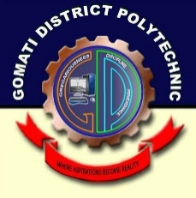

**Department of Computer Science & Technology**

Gomati District Polytechnic

Fulkumari, Udaipur, Gomati Tripura

Declaration

We, hereby declare that the project titled “Club Viewing Website”, is an original work carried out by us in the Department of Computer Science & Technology, Gomati District polytechnic, Fulkumari, Udaipur, Gomati Tripura, under the exceptional guidance of our supervisors, Subir Sir, Project Supervisor, H.O.D(I/C)

Department of Computer Science & Technology, Gomati District Polytechnic, Fulkumari, Udaipur, Gomati Tripura and Dibakar Sir, Lecturer/Lecturer (Sr. Scale), Department of Computer Science & Technology, Gomati District polytechnic, Fulkumari, Udaipur, Gomati Tripura. To the best of our knowledge and belief, it contains no material previously published or written by another person nor material which has been accepted for the award of any other degree or diploma of the University or other Institute of higher learning, except where due acknowledgment has been made in the text. The data and the findings discussed in the project report are the outcome of our project work. This report is being submitted to the Department of Computer Science & Technology, Gomati District polytechnic, Fulkumari, Udaipur, Gomati Tripura for the award of required credit towards minor project in 4th semester Diploma in Computer Science & Technology.

* **Anjishnu Nandi**

**(216305128)**

* **Rajdeep Debnath**

**(216305150)**

* **Tanmoy Majumder**

**(216305164)**

* **Purabi Das**

**(216305122)**

* **Naihrit Chakraborty**

**(216305145)**

* **Bibek Debnath**

**(216305134)**

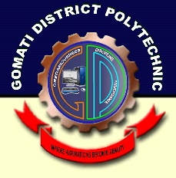

**Department of Computer Science & Technology**

Gomati District Polytechnic

Fulkumari, Udaipur, Gomati Tripura

Certificate of Approval

This is to certify that the minor project titled “Club Viewing Website”, submitted by Anjishnu Nandi, Rajdeep Debnath, Tanmoy Majumder, Naihrit Chakraborty, Purabi Das and Bibek Debnath to the Department of Computer Science & Technology, Gomati District polytechnic, Fulkumari, Udaipur, Gomati Tripura, towards partial fulfillment of the requirements for the award of Diploma in Information Technology is a bonafide project work carried out by them under our supervision and guidance. This work has not been submitted previously for any other degree or diploma of this or any other University. It is further certified that the candidates have complied with all the formalities as per requirements of Tripura University. The minor project report may be recommended to be placed before the examiners for consideration of awarding required credit towards minor project in 4th semester Diploma in Computer Science & Technology.

**Dibakar Sir**

Project Supervisor, Lecturer (Sr. Scale)

Department of Computer Science & Technology

Gomati District Polytechnic

Fulkumari, Udaipur, Gomati Tripura

**Mr. Subir Saha**

Project Supervisor, H.O.D(I/C)

Department of Computer Science & Technology

Gomati District Polytechnic

Fulkumari, Udaipur, Gomati Tripura

Certified that the work contained in the minor project titled “Club Viewing Website”, by Anjishnu Nandi, Rajdeep Debnath, Tanmoy Majumder, Naihrit Chakraborty, Purabi Das and Bibek Debnath is in compliance with the formalities as per requirements of Tripura University for the award of required credit towards minor project in 4th semester Diploma in Computer Science & Technology.

**External Examiner**

Principal

Gomati District Polytechnic

Fulkumari, Udaipur, Gomati Tripura

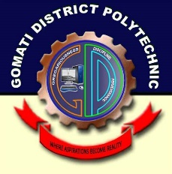

Department of Computer Science & Technology

Gomati District Polytechnic

Fulkumari, Udaipur, Gomati Tripura

Acknowledgement

A project is always the result of team work. In course of making the project a reality. we have accepted suggestion and help from various people without whose help this project would not have been successful.

We have great pleasure to express our deepest feelings of gratitude to Dibakar Sir

Project Supervisor Lecturer (Sr. Scale), Department of Computer Science & Technology Subir Sir Lecturer, Department of Computer Science & Technology, Gomati District polytechnic, Fulkumari, Udaipur, Gomati Tripura, who, as our supervisor has extensively helped in completion of this work with valuable suggestions, guidance, cooperation, patience and motivation. His advice, encouragement and critics were always the source of inspiration. We do consider ourselves very lucky for having carried out our project work under his supervision.

We would like to express our gratitude to ………. Head, Department of Computer Science & Technology, Gomati District polytechnic, Fulkumari, Udaipur, Gomati Tripura, for providing us with requisite facilities and also motivating and inspiring us to excel in life.

We would also like to take this opportunity to express our sincere thanks to our respected Principal sir ………….. for instilling in us the aspirations of achieving success in life through his motivational talks and lectures.

We would like to thank all the faculties, teaching and non-teaching staff members of this Institute and also all colleagues of Computer Science & Technology Department, who have helped us directly or indirectly for the completion of our work.

Last but not the least, most importantly, we are thankful to our family members for providing us with their unfailing support, understanding and love.

**Anjishnu Nandi (216305128)**

**Rajdeep Debnath (216305150)**

**Naihrit Chakraborty (216305145)**

**Purabi Das (216305122)**

**Tanmoy Majumder (216305164)**

**Bibek Debnath (216305134)**